Lab 2 Report

Evan Stewart

8/27/2018

**Data Type Table**

**GitHub Link to source code:** <https://github.com/Evan6678/Lab2-DataTypePrinter>

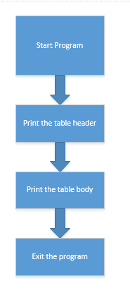

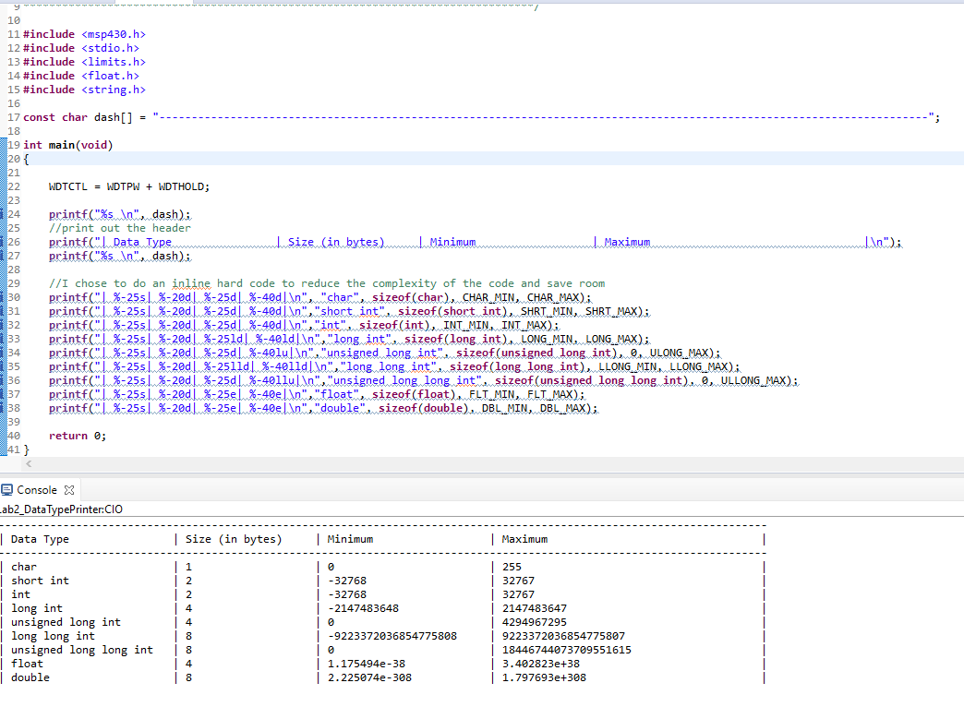

**Array Calculator**

**GitHub Link to source code:** <https://github.com/Evan6678/Lab2_ArrayCalc>

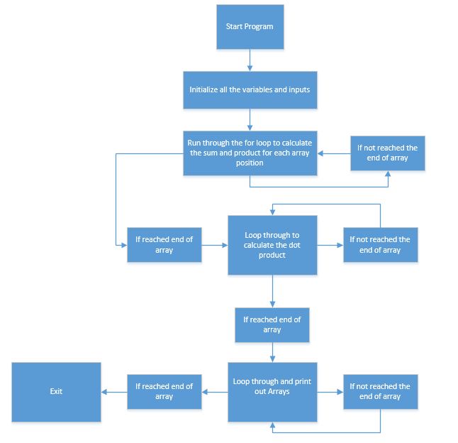

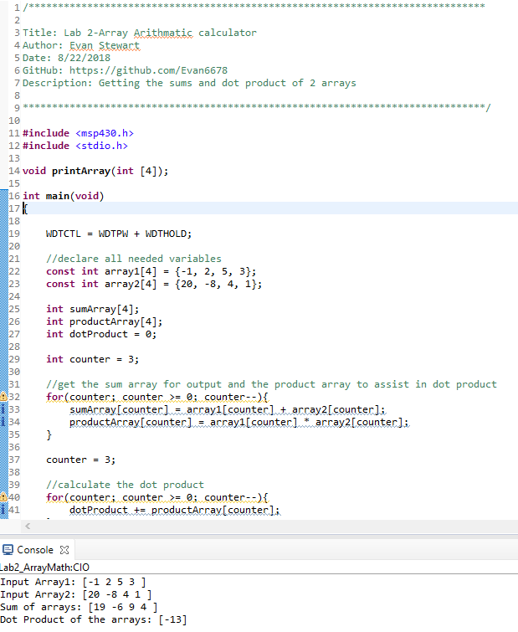

**Matrix Calculator**

**GitHub Link to source code:** <https://github.com/Evan6678/Lab2_MatrixCalc>

